Dignity Is a Baseline: Welfare Institutions and the Asymmetric Politics of Economic Disruption
Ben Smart
University of Copenhagen — Department of Economics
Welfare State Seminar — April 2026
Abstract
Workers in routine-task-intensive (RTI) occupations across Europe are more anti-immigration than their material interests would predict, and this gap is systematically wider in some welfare states than in others. The dominant scholarly reading treats welfare generosity as compensation, on the assumption that more generous provision will dampen the political resentment of the dislocated. Drawing on the European Social Survey rounds 6-9 (34 countries, N=188,764), I argue this compensatory framework is the wrong dimension. Welfare spending effort, on a matched 15-country sample, is uncorrelated with how strongly RTI exposure converts into exclusionary attitudes (r=0.01, N=15), while welfare decommodification, articulated by Esping-Andersen (1990) as the degree to which workers can sustain themselves without reliance on the market, accounts for 72 per cent of the same variation (r=−0.85). Indeed, the damage side of the mechanism is robust across every specification, while the mirror image on the solidarity side is not. RTI predicts slightly more redistribution support across all regimes, but welfare context does not detectably moderate that pathway, and a supplementary ISSP test on a different sample and outcome returns the same null. Through this perspective, the paper develops the theoretical claim that welfare institutions are asymmetric in their political effects: they can fail politically by damaging the self-concept of vulnerable workers and triggering a cascade of identity switching (Bonomi, Gennaioli & Tabellini 2021), misattribution (Gallego & Kurer 2022), and defensive othering (Wagner 2022), but they cannot, by symmetric operation, succeed. The asymmetry is undergirded by loss aversion, the inherently positional character of status (Gidron & Hall 2017), and the irreversibility of defensive identity investments. As Kurer (2020 p.1801) puts it, "when relative societal decline rather than material hardship are at the heart of socially conservative resentment, traditional welfare policy may be an insufficient response". This paper specifies which institutional dimension does the work, and which way it runs.
I. Introduction
Since the foundational contributions of Autor, Levy, and Murnane (2003) on the task-based framework, a robust finding has emerged across comparative political economy that workers in routine-task-intensive (RTI) occupations disproportionately support populist radical right parties (Gingrich 2019; Kurer 2020; Im et al. 2019; Autor et al. 2020; Gallego and Kurer 2022). The pattern is particularly observable in countries with weaker welfare provision (Vlandas and Halikiopoulou 2022; Caselli et al. 2021), leading scholars to argue welfare generosity moderates the relationship between economic vulnerability and exclusionary politics. Indeed, undergirding much of this comparative welfare state literature is Ruggie's (1982) framework of embedded liberalism, in which democratic governments, recognising that economic openness produces losers, provide social protection as compensation, on the assumption that compensation will dampen the political resentment of the dislocated. Effectively, the operative variable is purported to be quantity. Spend more, get less populism.
However, an accumulating body of empirical research suggests this compensatory framework is missing the mechanism it claims to describe. Gallego and Kurer (2022) flag what they themselves call a "concerning finding" in Gingrich's (2019) cross-national analysis, in which workers highly exposed to automation are not less likely to vote for populist parties in countries with more generous early retirement, more in-kind spending, or more protective labour market regulation. Furthermore, Stutzmann (2025) finds that affected municipalities in Germany's coal phase-out, despite receiving substantial compensatory investment, showed both higher abstention and lower support for the issue-owning party. Similarly, Pelc (2025) demonstrates that a sizeable share of workers resist being compensated out of work even where the compensation fully replaces their income, while Fetzer's (2019) analysis of Brexit indicates that welfare cuts predicted Leave support not through material deprivation but through the erosion of political trust and efficacy. Through these perspectives, Kurer (2020 p.1801) names the tension directly:
> "when relative societal decline rather than material hardship are at the heart of socially conservative resentment, traditional welfare policy may be an insufficient response to satisfy exposed workers and hence an ineffective remedy to counter the ascent of right-wing populist movements".
Kurer and Palier (2019) make a complementary argument with stronger phrasing, contending that "this appeal to personal dignity is key to winning routine workers' support. Perhaps even more than social protection, they demand economic and cultural protection". Both contributions, alongside Gidron and Hall's (2017 p.26) finding that right-populist voters "care as much, or even more, about recognition as about redistribution", suggest the dominant compensatory framework treats redistribution and recognition as fungible when, on the empirical record, they are not. Thus, the question is not whether welfare matters, but along which institutional dimension its political consequences actually travel.
The empirical contribution of this paper is to take Kurer's claim literally and identify the dimension. Drawing on the European Social Survey rounds 6-9 (34 countries, N=188,764), I find that welfare spending effort, on a matched 15-country sample, is uncorrelated with how strongly automation exposure converts into exclusionary attitudes (r=0.01, p=0.97). By contrast, welfare decommodification, articulated in Esping-Andersen's (1990) classic formulation as the degree to which a person "can maintain a livelihood without reliance on the market", accounts for 72 per cent of the same cross-national variation (r=−0.85, p<0.001). This is not a story about quantity. It is a story about what welfare institutions actually do to the people inside them, and what they say about those people in the doing.
What welfare says, I argue, is the mechanism. Welfare is the single state domain in which economic vulnerability and institutional treatment meet at the same moment: when a worker encounters the welfare state, the institution allocates resources and renders a judgement about the worker's claim to those resources, in the one act. As purported by Wagner (2022), recipients consequently "internalize deservingness criteria" and "mirror" them onto others, producing what she terms a "kicking down" dynamic that "typically ends with blaming of immigrants (welfare chauvinism)". Through this perspective, what welfare communicates determines whether economic disruption is processed through class identity, where it can support solidarity, or routed through cultural identity and the cascade developed in §III, where it perpetuates exclusion.
This generates a stronger theoretical claim than the symmetric compensatory account it replaces. The political effects of welfare design, I contend, are asymmetric. Welfare institutions can fail politically in a specific, cumulative way; they damage the self-concept of vulnerable workers and trigger a cascade of identity switching (Bonomi, Gennaioli & Tabellini 2021), misattribution (Gallego & Kurer 2022), and defensive othering (Wagner 2022; Patrick 2016). They cannot, by symmetric operation, succeed. Indeed, variation in how routine workers convert disruption into exclusion is robust across every specification of this paper's data, while the variation in how those same workers convert the same disruption into redistributive solidarity is small, non-significant, and not detectably moderated by welfare context. Dignity-preserving welfare clears the ground for solidarity, but it does not, by itself, produce it.
The paper proceeds in three substantive moves. Firstly, it connects three previously-isolated micro-mechanisms - identity switching, misattribution, and defensive othering - into a single damage cascade, with welfare institutional design as the upstream condition under which the cascade fires. Secondly, it argues that no symmetric mirror image of this cascade exists, undergirding the asymmetry in loss aversion (Kahneman and Tversky 1979), the inherently positional character of status, and the irreversibility of defensive identity investments once they have been made. Thirdly, it provides cross-national empirical evidence that the political consequences of welfare design are visible only when welfare is measured by decommodification rather than by spending; a finding that points the empirical agenda toward dimensions of welfare design that have been treated as descriptive detail rather than as the place where the political action is.
II. The Limits of the Buffering Model
The dominant framework treats the welfare state as a buffer against political extremism. Its theoretical foundation is Ruggie's (1982) embedded liberalism bargain: democratic governments, recognising that economic openness creates losers, provide social protection as compensation, on the expectation that compensation dampens extremism. Contemporary applications test whether welfare generosity reduces radical right support (Vlandas and Halikiopoulou 2022; Halikiopoulou and Vlandas 2016; Ennser-Jedenastik et al. 2019). The operative variable is quantity. Spend more, get less populism.
But the evidence is harder on the framework than this account allows.
Compensation that does not work. Gallego and Kurer (2022) flag what they call a "concerning finding" from Gingrich's (2019) comparative study, the only careful cross-national analysis testing whether public policies aimed at alleviating labour market risks for automation-exposed workers prevent the political turn to protest voting. Gingrich finds that workers highly exposed to automation are not less likely to vote for populist parties in countries with more generous early retirement policies, more in-kind spending, or more protective labour market regulation. If the buffering model were correct, more generous welfare states should show weaker automation-to-populism effects. They do not.
Compensation that backfires. Stutzmann (2025) examines Germany's coal phase-out, a case where affected communities received substantial compensatory investment and where both compensation and interest group representation were fulfilled. Material conditions held; affected municipalities nonetheless showed higher abstention rates and lower support for the issue-owning party. Bergman (2023) theorises "self-undermining" policy feedback effects, whereby welfare interventions visibly benefiting groups that potential radical right voters view unfavourably can catalyse greater support for the radical right. Fetzer's (2019) analysis of Brexit makes the channel explicit: welfare cuts predicted Leave support through the erosion of political trust and efficacy, rather than through material deprivation. The institutional channel is doing the political work.
Compensation that is resisted. Pelc (2025) shows that a sizeable portion of workers resist being compensated out of work even when the compensation fully replaces their income, preferring reduced hours over unemployment at the same pay, and compensation from employers over identical compensation from government. The form, source, and meaning of compensation carry political weight independently of its material content. As Guriev (2024) observes, compensating the losers of economic transformation has proven much harder than economists assumed, not because of insufficient resources, but because of political and institutional constraints the buffering framework does not theorise. Kuziemko (2023) makes the complementary point on the demand side. Less-educated voters in the United States prefer predistribution (wage protection, work supports) over redistribution as such, suggesting the resistance Pelc documents is characteristic rather than anomalous.
Burgoon and Schakel (2022) provide the most careful recent empirical case for the buffering account, and the apparent contradiction with this paper's null on welfare spending is worth resolving directly. They find welfare generosity associated with reduced anti-globalization nationalism in European party platforms. Their result is real and their measurement careful. The contradiction dissolves once the units of analysis are kept distinct: Burgoon and Schakel measure platform language at the party level, while the analysis here measures attitudinal slopes at the individual level conditional on automation exposure. The mechanisms that translate aggregate welfare effort into party platforms (elite incentives, coalition arithmetic, electoral targeting) differ from the mechanisms that translate institutional encounter into individual self-concept and exclusionary attitudes. Both findings can be true. Welfare generosity at scale may dampen the supply of anti-globalization rhetoric in party systems while the demand for exclusionary attitudes among vulnerable workers responds to a different welfare dimension entirely. The contribution of this paper is to identify that dimension as decommodification rather than spending effort, and to locate it at the individual rather than party level.
The buffering model is not entirely wrong. Albanese et al. (2021) find that EU structural fund disbursements reduce populist voting in recipient regions, suggesting visible, tangible local investment can work where individualised transfers cannot. The finding cuts the same way as the asymmetric argument developed below. What the spending says about recipients, and about their relationship to the political community, is what does the work. Spending effort alone is too coarse.
III. The Asymmetric Mechanism
A. What the Evidence Demands
The central empirical pattern of §V is asymmetric. Welfare institutional context moderates the conversion of automation exposure into anti-immigration sentiment: the slope is significantly steeper in Liberal regimes than in Nordic ones, and the moderation tracks decommodification rather than spending. It does not detectably moderate the conversion of the same exposure into redistributive solidarity. RTI predicts slightly higher redistribution support across all regimes, but the cross-regime interaction is small and non-significant, and a supplementary ISSP analysis (Appendix C) returns the same null on a different sample and outcome variable. The damage mechanism is legible. The protective one is not.
The natural response is to treat the solidarity null as a measurement problem. The supplementary analysis suggests the null survives a few obvious alternatives, and on my reading it is also robust to the more defensible interpretation: the mechanism itself is asymmetric. Welfare institutions can fail politically, in a specific and cumulative way. By symmetric operation, they cannot succeed.
The recognition literature has been working toward this claim for some time. Gidron and Hall (2017, p.26) find that right-populist voters "care as much, or even more, about recognition as about redistribution," and that compensation "is not what these people are looking for." Kurer and Palier (2019) make the complementary point in the routine-worker context: what routine workers demand is "economic and cultural protection," and the second of those cannot be supplied through transfer payments. Redistribution and recognition are not fungible. The asymmetric mechanism takes that non-fungibility as its starting point.
B. Why Welfare, and Not Something Else
The obvious objection is that many institutions shape identity. Media environments construct group boundaries; religious traditions supply moral narratives; class structures generate interest coalitions. Why isolate welfare?
The answer is that welfare is the single state domain where economic vulnerability and institutional treatment meet. When a worker encounters the welfare state, the institution allocates resources and renders a judgement about that worker's claim to them, in the same act. Other identity-shaping institutions cannot match the combination. Courts render judgement but rarely allocate resources to the individual judged; markets allocate without judgement, or pretend to; religious institutions render judgement but cannot compel. Only welfare does both, and at the point of a person's maximum material dependence.
Wagner's (2022) finding that recipients learn and mirror the recognition norms the state enacts on them is intelligible only under these conditions. Because the encounter is materially consequential and judgement-laden, recipients cannot dismiss the signal as one view among many; they have to metabolise it. Soss (1999) documents the specific learning. Programmes with respectful implementation foster civic engagement; programmes characterised by surveillance and conditionality generate alienation, and the alienation persists. De Blok and Kumlin (2022) extend the point: procedural fairness preserves institutional trust most strongly for those whose outcomes are unfavourable, which means implementation quality matters most precisely for those who are most economically vulnerable. What the welfare state says about you, when you encounter it, is part of what you know about yourself.
The mechanism scales beyond direct recipients through three channels. Workers anticipating future dependency factor present welfare treatment into present self-understanding. Public discourse mirrors recipient-level recognition norms (Wagner 2022). And routine-task-intensive workers are concentrated in welfare caseloads, anticipated and actual; this is why the cross-national pattern is detectable in ESS data. A structurally distinct fourth channel runs through Mettler's (2011) "submerged state": tax expenditures and indirect benefits serving middle and upper-income groups that remain invisible as government assistance. Recipients of submerged welfare attribute their security to personal merit; recipients of visible welfare are marked as dependents. The two groups look at the same welfare state but see different institutions, producing a political identity fracture in which a large share of the population benefits from the welfare state without recognising it.
C. The Damage Cascade
When welfare institutions damage the self-concept, three responses follow, each harder to reverse than the one before.
The first is identity. Bonomi, Gennaioli, and Tabellini (2021) model how individuals move from class to cultural identity when class identity is degraded by economic disruption, and under cultural identity redistribution demand decreases while cultural conservatism intensifies. The welfare state enters at a specific point: stigmatising implementation degrades class identity directly. A worker entering a system that treats retraining as a citizenship right retains class identity; a worker entering a system of means-testing and surveillance has it doubly damaged, by the disruption and by the system's response to him. Ballard-Rosa, Jensen, and Scheve (2022) provide the downstream evidence: economic decline activates social identity processes producing authoritarian values through group status threat. Welfare institutional mediation, I argue, is the missing upstream variable. Im (2023) confirms in Finnish panel data that expected status decline, not material hardship as such, drives the radical right shift among routine workers, and expectations are themselves shaped by what workers observe of how the state treats people in their position.
Once cultural identity is in charge, grievances misattribute. Economic frustration gets pointed at cognitively available scapegoats. Wu (2022) confirms the misdirection empirically: workers at higher automation risk oppose immigration but show no different technology preferences. There is no analogue on the protective side; no condition under which structural attribution emerges as a substitute for the cultural attribution workers would otherwise have made. Alesina and Angeletos (2005) provide the institutional anchor: conditional welfare systems produce individual rather than structural attributions.
The third move is defensive othering. Patrick (2016) documents what this looks like at the recipient level: UK benefit claimants shoring up their own deservingness through critique of those below them, using the same criteria the welfare system applied to them. Wagner (2022) calls it "kicking down" and documents its institutional origins. Im and Komp-Leukkunen (2021) connect it to automation: routine workers support strict conditionality because it maintains status distance from groups below them, not because strict conditionality is in their material interest. The cascade ends in a configuration Busemeyer, Rathgeb, and Sahm (2023) name precisely: the "particularistic-authoritarian" welfare preference, pro-workfare and anti-poor and anti-social-investment, the political programme of a self-concept the welfare state has helped construct.
D. Why the Mirror Image Does Not Exist
The symmetric account would predict that welfare institutions which preserve the self-concept produce solidarity through a mirror-image cascade: stable identity, structural attribution, inclusive deservingness. The paper's empirical null on the solidarity side says otherwise, and on my reading the null is what the mechanism actually predicts.
Three different things are wrong with the symmetric picture. Loss aversion comes first. Kahneman and Tversky's (1979) finding, that losses loom larger than equivalent gains in evaluation, applies directly to dignity shocks. A stigmatising welfare encounter registers as a status loss; a dignity-preserving encounter does not register as a status gain of equivalent magnitude. What it produces is the absence of damage, which has a different psychological signature and a different political one. Damage mobilises; the absence of damage tends not to. Kurer and van Staalduinen (2022) document the closely related asymmetry in intergenerational status discordance: voters whose expectations are unmet show large political shifts, while voters whose expectations are exceeded show much weaker ones.
Second, status is positional. There is no quantity of status one person can have without another person having less. Gidron and Hall (2017) make the point exactly: what right-populist voters want is recognition in the relational sense, not redistribution in the material sense, and relational goods cannot be redistributed without losses to the currently-recognised. Dignity-preserving welfare removes an obstacle to inclusive solidarity; it does not, by itself, construct the inclusion. Active solidarity requires political work that welfare design alone cannot do (Iversen and Soskice 2001; Rothstein 2001; Larsen 2008). Welfare provides permission, not propulsion.
Third, defensive othering, once committed to, is costly to reverse. A worker who has built their own deservingness on critique of those below them has made an identity investment, and identity investments are not undone by changing the institutional environment alone; they require the un-doing of identity work that has already happened. The cascade is self-sustaining at every step: conditional welfare damages self-concepts, damaged self-concepts produce othering, othering generates public attitudes supporting further conditionality, political entrepreneurs respond with welfare chauvinism, further conditionality deepens the damage. Pierson's (1994) positive feedback describes constituencies whose identities grow into support for policies they benefit from. The damage cascade runs the other way: into a population that has forgotten the position it now defends was constructed for it. Haugsgjerd and Kumlin's (2020) "downbound spiral" picks up the individual-level signature in panel data; Van Hootegem, Abts, and Meuleman (2021) name the attitudinal contradiction it produces, with citizens simultaneously endorsing redistribution in principle and distrusting the welfare state in practice.
Three asymmetries, none with a mirror image. Dignity is a baseline good. Its absence damages. Its presence clears the ground for a solidarity that has to be built on top, by other means.
E. What the Asymmetric Theory Predicts
A theory of this shape has to be testable. The asymmetry generates predictions sharp enough to fail. Cross-national variation in exclusion should track dimensions of welfare design that bear on dignity (decommodification, conditionality, the punitive-enabling balance of ALMP; see Van Hootegem 2025) but not welfare spending effort, because spending is orthogonal to dignity. This is what §V.D tests. Cross-national variation in solidarity should not track the same welfare design variables with anything like the same strength, because solidarity requires supply-side construction (political entrepreneurship, coalitional framing, electoral system affordances) that welfare quality alone cannot provide. This is what §V.F tests. And what makes Nordic welfare states distinctive should be the absence of steep exclusion slopes, not the presence of redistributive uplift. The data behaves accordingly: Nordic RTI→exclusion slopes are the flattest in Europe.
Two further predictions live within rather than across countries, motivating the registry-based follow-up. Welfare reform introducing conditionality should show damage effects, while welfare reform expanding generosity should show weaker or null protective effects. And panel data should detect path-dependence in individual attitudes, with workers who experience a stigmatising encounter showing elevated exclusionary attitudes years later. Three of the five predictions are tested here. Two are written so that, in the thesis, they can be falsified.
IV. Scope Conditions and Limits
The asymmetric mechanism claims something narrower than its symmetric cousin: welfare institutions are the institutional condition under which the damage cascade fires, and no symmetric institutional condition produces a mirror-image solidarity cascade. Three limits bound the claim.
The absence of damage is necessary but not sufficient for solidarity. Universal programmes build social trust (Rothstein 2001) and produce inclusive deservingness narratives (Larsen 2008); extensive universal provision conveys recognition beyond material security (Häusermann 2024); Nordic welfare states show consistently lower populist support despite globalisation pressures (Norris and Inglehart 2019). All real. On the asymmetric reading, what these findings record is the baseline dignity-preserving welfare provides, not the active uplift the buffering model assumes. The political work that converts baseline dignity into active solidarity (Bornschier, Haffert, and Häusermann 2024; Jeffrey 2020) is out of scope here. Welfare design's role in that construction is permissive, not productive.
Welfare institutions also do not operate on a blank moral slate. Pelc's (2025) finding that Protestant work ethic predicts compensation resistance independently of material incentives suggests some attitudes exist prior to institutional contact. The welfare state shapes moral frameworks, but it also inherits them.
The loss aversion claim in §III.D borrows from behavioural economics by analogy. Supporting empirical work (Kurer and van Staalduinen 2022; Häusermann 2024) is consistent with the claim but does not test it directly. The within-individual test belongs to the registry-based follow-up. The cross-sectional finding here is large, robust, and predicted by the theory; it remains provisional in a way the asymmetric framing itself acknowledges.
V. Empirical Analysis
A. Data and Measurement
The analysis uses the European Social Survey (ESS), rounds 6–9 (fieldwork 2012–2018), covering 34 countries and 188,764 observations.
Automation exposure is measured by routine task intensity (RTI) scores mapped to three-digit ISCO-08 occupation codes following Autor, Levy, and Murnane (2003) and Goos, Manning, and Salomons (2014). Match rate: 87.8% (N=165,667).
Exclusionary attitudes are measured by a three-item anti-immigration index (whether immigrants make the country worse, undermine cultural life, or are bad for the economy; reverse-coded 0–10; Cronbach's α=0.864).
Welfare institutional context is operationalised in three ways. Countries are classified into welfare regimes following Esping-Andersen (1990) and Ferrera (1996): Nordic (DK, SE, NO, FI, IS), Continental (DE, FR, AT, BE, NL, CH), Liberal (GB, IE), Southern (ES, IT, PT, CY), and Eastern (CZ, PL, HU, SK, SI, EE, LT, LV, BG, HR). Country-level ALMP spending (% of GDP) is drawn from the CPDS (22 countries). Total welfare generosity from the Comparative Welfare Entitlements Dataset (CWED), measured as the mean decommodification score across unemployment, sickness, and pension programmes for 2005–2011 (15 Western European countries).
Controls include age, age squared, gender, education (ES-ISCED), household income decile, and urban/rural residence.
B. Empirical Strategy
The core test is a cross-level interaction:
Y_ij = β₀ + β₁(RTI_i) + β₂(Welfare_j) + β₃(RTI_i × Welfare_j) + γ(X_i) + u_j + ε_ij
where β₃ tests whether the conversion of automation exposure into exclusionary attitudes depends on welfare institutional context. I estimate mixed models with country-wave random slopes for RTI (1 + RTI | country-wave), confirmed over random intercepts alone by likelihood ratio test. OLS with country-wave fixed effects and clustered standard errors serves as a robustness check; results are directionally identical. The cross-sectional design cannot establish causality. I test whether the pattern is consistent with the asymmetric mechanism developed in §III and inconsistent with the symmetric "more spending = less backlash" alternative.
C. Descriptive Results
Figure 2 presents the central descriptive finding. Across all welfare regimes, higher RTI is associated with more anti-immigration attitudes; the relationship is positive and significant everywhere. The slope is steepest in Liberal regimes (β=0.512), followed by Southern (β=0.462), Continental (β=0.443), Nordic (β=0.413), and Eastern (β=0.263). The marginal effects plot (Figure 3) makes the comparison precise: a one-standard-deviation increase in RTI is associated with approximately 0.32 additional scale points of anti-immigration sentiment in Liberal regimes, compared to 0.20 in Nordic regimes. The gap is statistically significant and substantively meaningful.
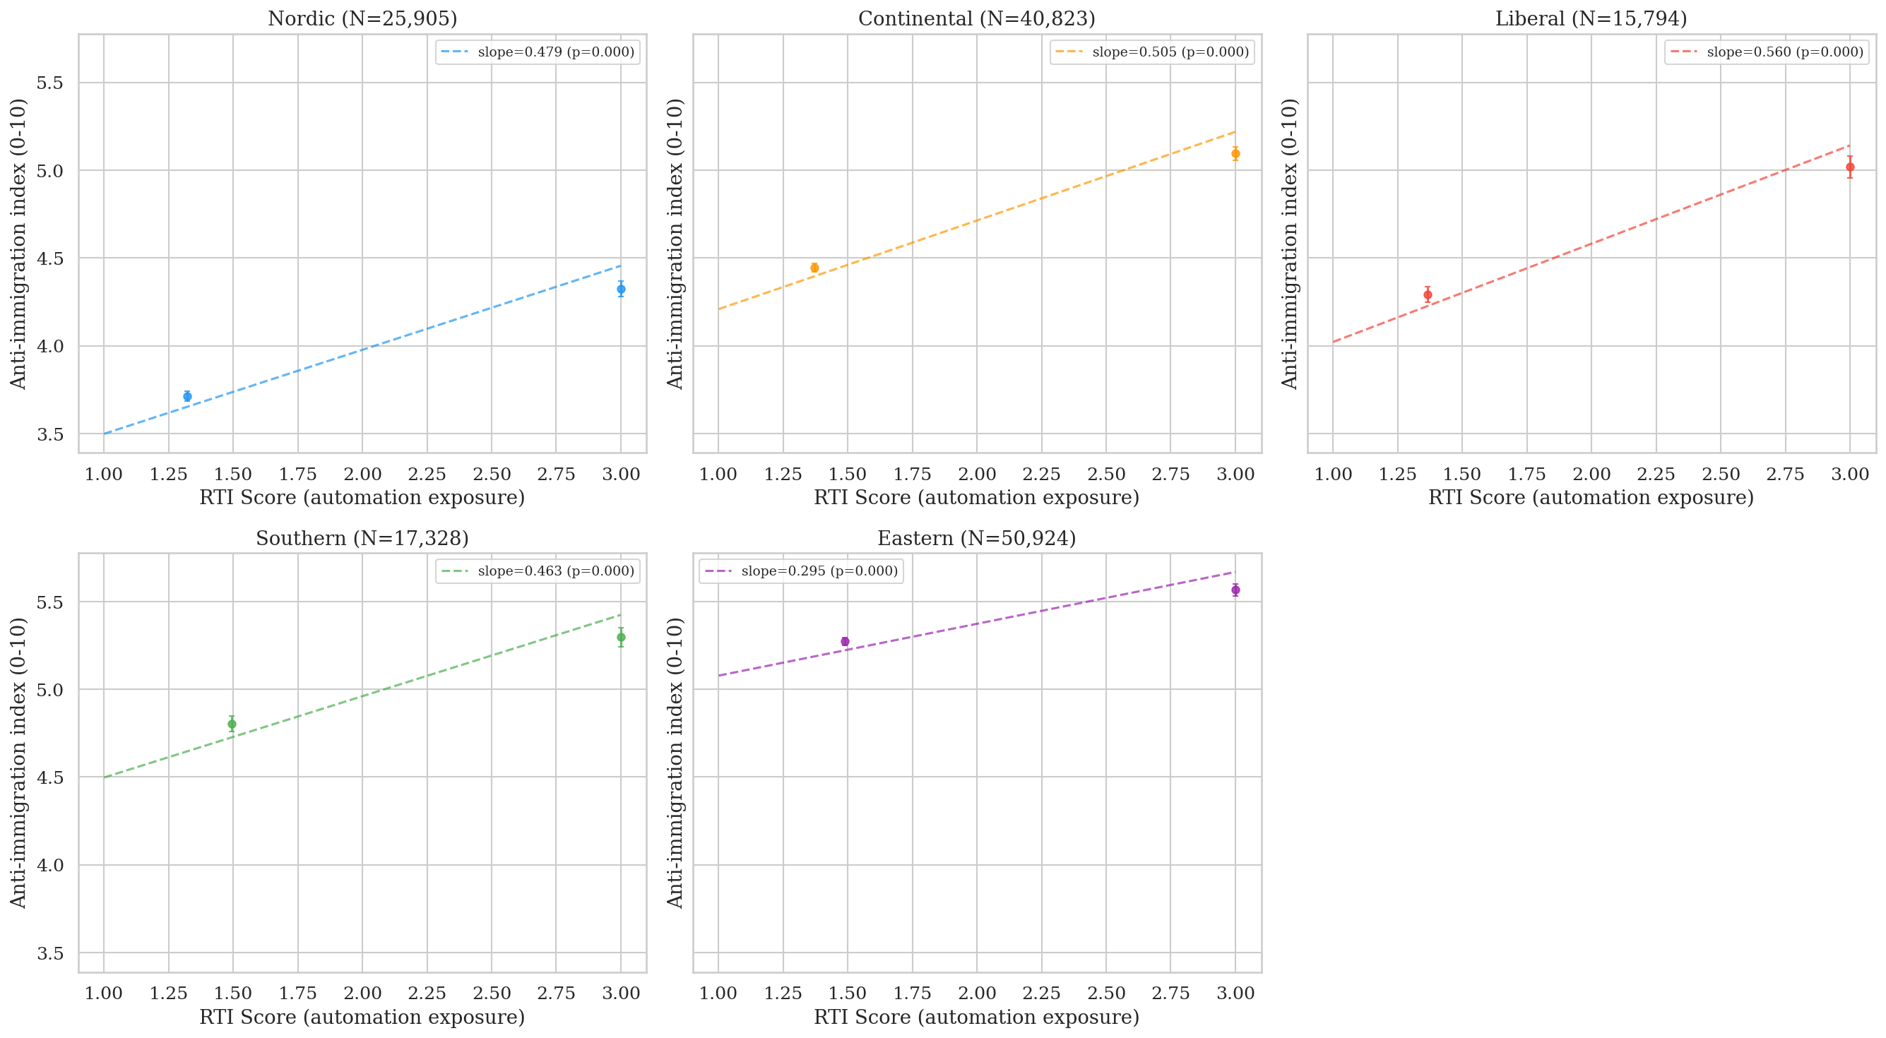
Figure 2. RTI vs. anti-immigration by welfare regime. Five-panel binned scatter.
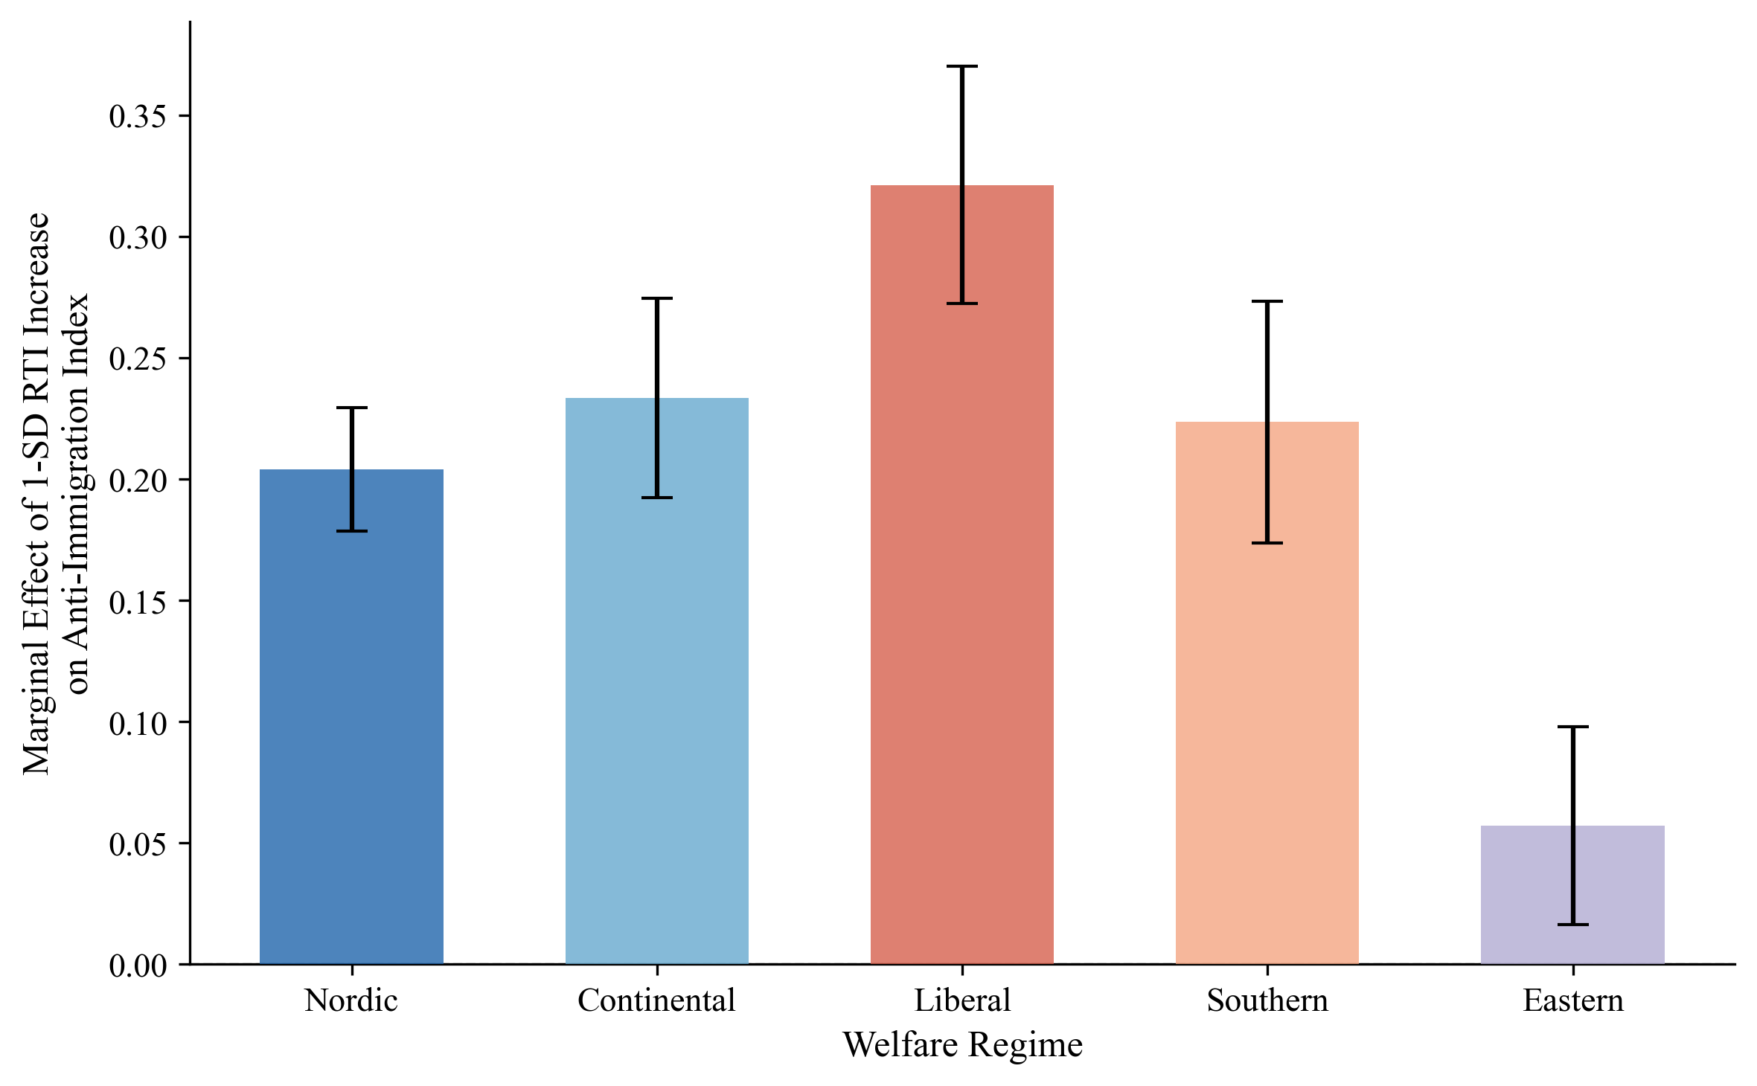
Figure 3. Marginal effect of 1-SD RTI increase by welfare regime.
D. The CWED Finding: Decommodification as the Operative Variable
Comparing two welfare measures produces the paper's most important finding. When individual countries' RTI→anti-immigration slopes are plotted against their ALMP spending levels (restricting to the same 15 Western European countries used in the CWED analysis), the correlation is near-zero (r=0.01, p=0.97, N=15). Countries spending more on active labour market policies show no systematically flatter or steeper vulnerability-to-exclusion slopes. Spending effort, holding sample constant, is unrelated to the exclusion pattern.
The picture changes dramatically when welfare is measured by its decommodifying quality. Figure 6 plots the same country-level slopes against CWED total generosity, the composite score capturing how effectively welfare systems enable workers to sustain living standards without employment. The correlation is strongly negative: r=−0.848, p<0.001, N=15 countries. Welfare generosity measured as decommodification is associated with 72 per cent of the cross-country variation in how strongly automation exposure co-varies with exclusionary attitudes. The United Kingdom, lowest in CWED generosity, shows the steepest slope. Norway, highest in generosity, shows the flattest.
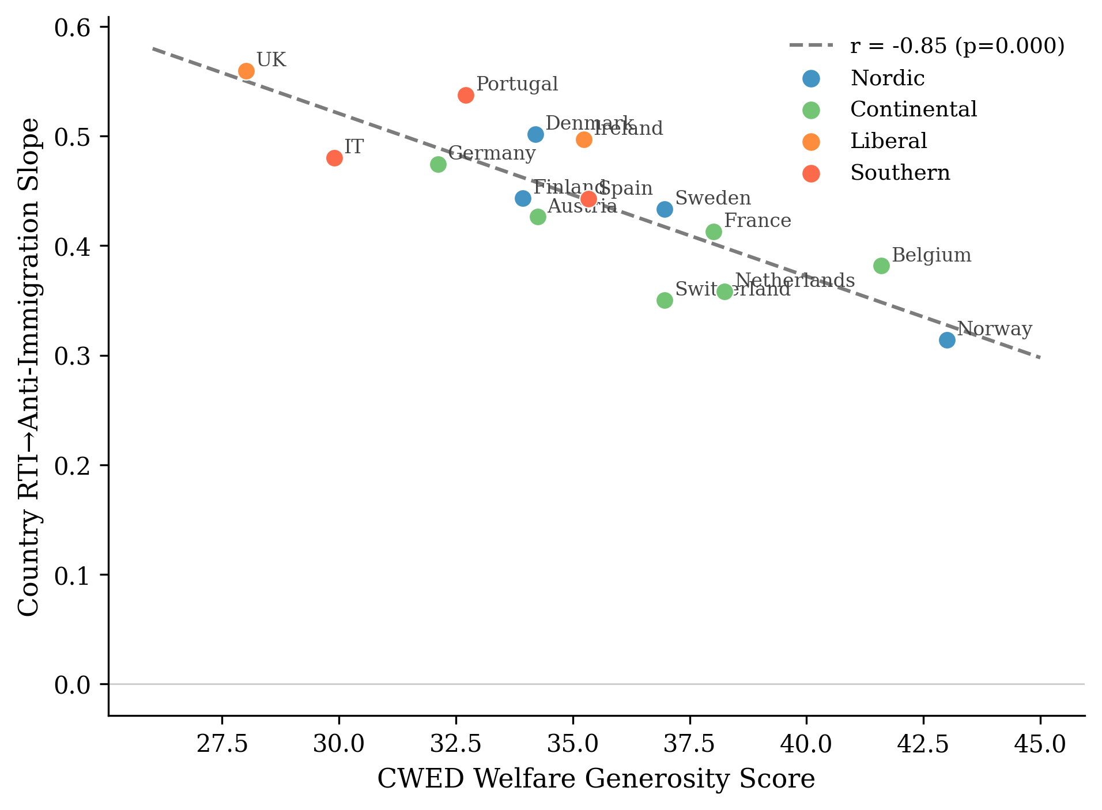
Figure 6. CWED generosity vs. country-level RTI→anti-immigration slopes.
At the individual level, Model 3 confirms this with the cross-level interaction:
Variable | β | SE | p
RTI | 0.215 | 0.025 | <0.001
CWED generosity | -0.069 | 0.064 | 0.281
RTI × CWED generosity | -0.059 | 0.024 | 0.015
The interaction is negative and significant (β=−0.059, p=0.015, N=81,885): a one-standard-deviation increase in welfare generosity reduces the marginal effect of RTI on anti-immigration attitudes by 0.059 scale points. The larger standard error relative to earlier specifications reflects the conservative random-slopes estimator, which absorbs cross-national slope heterogeneity. The finding strengthens with country-level GDP growth and Gini controls (β=−0.066, p<0.001), arguing against the concern that decommodification proxies for broader economic conditions.
The ALMP/CWED contrast is the paper's central empirical argument, and it maps directly onto the theoretical distinction in §III. Bonoli's (2013) typology and the more recent treatment in Van Hootegem (2025) explain why: ALMP aggregates across enabling programmes (upskilling, employment counselling) and punitive ones (benefit sanctions, behavioural conditionality), so the political signature of the punitive subset cancels out against the enabling subset. CWED measures what the welfare state provides rather than what it demands, which is the asymmetric mechanism's exact prediction.
Denmark presents an instructive complication. Despite high CWED generosity, Denmark shows a relatively steep RTI→exclusion slope (β=0.50), higher than Finland, Sweden, or Norway. Danish "flexicurity" combines generous benefits with high labour market flexibility and active job search requirements, creating a system generous in transfers but demanding in activation. On the asymmetric reading, this is not an anomaly but an additional piece of evidence: conditionality and surveillance damage the self-concept even when transfer levels are high. The activation-introducing reforms of 2003, 2006, and 2013 are exactly the kind of within-country shock the asymmetric theory predicts should produce damage signatures with decommodification held constant. The country-level finding is robust to all single-country exclusions: excluding the United Kingdom (lowest CWED) gives r=−0.802; excluding Norway (highest CWED) gives r=−0.794; excluding both simultaneously gives r=−0.717 (p=0.006).
E. Main Models
Table 2 presents the multilevel results. Model 1 confirms that RTI predicts anti-immigration attitudes after controls (β=0.168, p<0.001, N=133,016). Model 2 introduces regime interactions with Nordic as reference:
Interaction | β | SE | p
RTI (Nordic baseline) | 0.194 | 0.025 | <0.001
RTI × Continental | 0.034 | 0.032 | 0.288
RTI × Liberal | 0.127 | 0.043 | 0.003
RTI × Southern | 0.029 | 0.039 | 0.454
RTI × Eastern | -0.132 | 0.031 | <0.001
Automation exposure is associated with anti-immigration sentiment significantly more strongly in Liberal welfare regimes than in Nordic ones (β=0.127, p=0.003). A one-standard-deviation increase in RTI is associated with 0.127 additional scale points of anti-immigration sentiment in Liberal compared to Nordic contexts, after controlling for individual characteristics. The larger standard errors compared to fixed-effects specifications reflect the random-slopes estimator; the substantive pattern is unchanged.
F. The Asymmetric Confirmation
The redistribution models confirm the asymmetric prediction set out in §III, and they do so in the place where the symmetric account most needed them to fail. RTI predicts slightly more redistribution support across all regimes (β=0.044, p<0.001). The cross-regime variation that drives the exclusion finding does not appear on the solidarity side: the RTI × Liberal coefficient is small, non-significant, and in the wrong direction (β=0.011, p=0.285). Welfare institutional context cleanly attenuates the conversion of vulnerability into exclusion. It does not detectably moderate the conversion of the same vulnerability into redistributive solidarity. That is the asymmetry, and it is more than the absence of a finding; it is what the theory predicted in §III.D and what the symmetric buffering account would have to deny.
The ISSP 2006 Role of Government module (N=10,216, 12 countries) provides a second test on a different sample, outcome, and time period. The result: no interaction between automation exposure and welfare generosity on unemployment spending support (β=+0.010, SE=0.016, p=0.55). A second null. The 2006 data predate the automation discourse of Frey and Osborne (2013) by several years; the protective pathway, on my reading, requires automation exposure to register as a salient class-level threat in public discourse before solidarity can be politically organised around it, while the damage pathway carries no such contextual requirement. The asymmetry is detectable across temporal contexts in which the underlying material vulnerabilities are themselves shifting.
A measurement-problem reading of the redistribution null is available, and I am not in a position to rule it out conclusively. The substantive reading, which the asymmetric theory predicts, is that the null is the paper's strongest confirmation: welfare design's political effects are real, mediated by decommodification rather than spending, and run more reliably toward damage than toward repair.
The radical right voting models (Model 6) require honest treatment. RTI predicts radical right voting in Nordic countries (β=0.220, p<0.001) but the RTI × Liberal interaction is negative and significant (β=−0.123, p=0.032), opposite in direction to the attitudinal finding. This is not a contradiction of the mechanism; it is what happens when supply-side institutions intervene between attitudes and votes (see §VI). The behavioural models are descriptive of electoral systems' translation of attitudes into votes, not tests of the asymmetric mechanism itself.
G. Limitations
Several limits matter for how to read these findings. The cross-sectional design cannot establish temporal ordering. Country-level welfare indicators are confounded with other institutional differences; Nordic countries with high CWED generosity also tend to have higher social trust, stronger unions, proportional electoral systems, and lower ethnic heterogeneity, and the macro-controls robustness check (GDP growth, Gini) addresses macroeconomic confounders but not these deeper institutional correlates. The CWED finding, while striking (r=−0.848), rests on 15 country-level observations. The individual-level Model 3 interaction provides a more defensible test, but full identification requires within-country variation in welfare generosity over time, exploiting CWED changes following benefit reforms; a design I intend to pursue with Danish registry data in subsequent work.
VI. Discussion and Conclusion
The evidence supports the asymmetric account theorised in §III. Welfare design shapes how economic disruption turns into exclusion. It does not equivalently shape how the same disruption turns into solidarity. Disruption processed through welfare institutions that preserve the self-concept does not, in this data, produce detectably stronger redistributive demand than disruption processed through institutions that damage it. Disruption processed through institutions that damage the self-concept does produce detectably stronger exclusionary attitudes. The damage mechanism is legible across every specification. The mirror-image protective mechanism is not.
The ALMP/CWED contrast bears directly on the theoretical argument. The buffering model asks how much the welfare state spends. The asymmetric mechanism asks what the welfare state communicates. A country can spend heavily on active labour market policies that are punitive, conditional, and dignity-stripping, and the spending will register as "generous" in conventional measures while communicating suspicion to the people on the receiving end. Decommodification captures what spending alone cannot: the degree to which the welfare state enables citizens to maintain their living standards and their sense of themselves without dependence on market employment. This is the institutional quality Banerjee and Duflo (2019) identify as the goal of social policy. It is what Kurer and Palier (2019) mean when they argue that routine workers demand "economic and cultural protection." And it is what Gidron and Hall (2017) document when they find that right-populist voters "care as much, or even more, about recognition as about redistribution." Three vocabularies, one institutional dimension.
The findings change the long-running debate about whether radical right support has "economic" or "cultural" roots. Ciccolini (2025) argues the distinction is flawed because voters give a cultural reading to economic phenomena, and the present paper pushes that argument in an institutional direction. Welfare design is part of what shapes whether economic disruption receives a cultural reading in the first place. Cultural backlash is not a rival explanation to the economic one; it is what economic disruption looks like, cross-nationally, where welfare institutions are less decommodifying. The cultural reading has no symmetric counterpart on the protective side.
The argument is about attitudinal sorting, not vote translation. The behavioural results in §V.F are better read as confirmation of that distinction than as a puzzle. Attitudes sort; supply-side institutions then determine whether attitudes become votes. Ireland has no electorally significant radical right party in this period. The UK's first-past-the-post system suppresses radical right seat conversion despite substantial UKIP vote shares; high-RTI Liberal-regime voters channelled exclusionary preferences into Brexit. A full account of how sorted attitudes become exclusionary politics is a separate paper.
The "dignity dividend" is a property of how welfare is experienced, of whether the encounter leaves a person feeling like a citizen or a supplicant. Standard generosity measures cannot capture it. The Danish 2003, 2006, and 2013 activation reforms introduced conditionality of exactly the kind the asymmetric theory predicts should produce damage signatures, with underlying decommodification levels held relatively constant; that is as close to a quasi-experimental setting on the dignity margin as the available data permits, and it is where the test the present paper cannot run will have to be run.
Decommodification, not spending, is the dimension of welfare design along which the political consequences of economic disruption are visible. The consequences themselves are asymmetric, clearly toward damage and much less reliably toward repair. The buffering model's instinct, that welfare design matters politically, is correct. Its specific account of how (symmetric, quantity-based) is wrong in a way the data and the theory now make legible together. Dignity is a baseline good. The buffering model has been treating it as a quantity.

References
Alesina, A. and Angeletos, G.-M. (2005). 'Fairness and Redistribution.' American Economic Review, 95(4), pp. 960–980.
Albanese, G., Ferretti, G., and Ferroni, G. (2021). 'EU Structural Funds and Populism.' Working Paper.
Autor, D. H., Dorn, D., Hanson, G. and Majlesi, K. (2020). 'Importing Political Polarization?' American Economic Review, 110(10), pp. 3139–3183.
Autor, D. H., Levy, F. and Murnane, R. J. (2003). 'The Skill Content of Recent Technological Change.' Quarterly Journal of Economics, 118(4), pp. 1279–1333.
Ballard-Rosa, C., Jensen, A. and Scheve, K. (2022). 'Economic Decline, Social Identity, and Authoritarian Values.' International Studies Quarterly, 66(1), sqab027.
Banerjee, A. and Duflo, E. (2019). Good Economics for Hard Times. PublicAffairs.
Bergman, T. (2023). 'Industrial Decline and the Populist Radical Right.' European Journal of Political Research, 62(2), pp. 521–545.
Bonoli, G. (2013). The Origins of Active Social Policy. Oxford University Press.
Bonomi, G., Gennaioli, N. and Tabellini, G. (2021). 'Identity, Beliefs, and Political Conflict.' Quarterly Journal of Economics, 136(4), pp. 2371–2411.
Bornschier, S., Haffert, L. and Häusermann, S. (2024). 'Cleavage Formation: Universalism–Particularism and Electoral Realignment.' Comparative Political Studies, forthcoming.
Burgoon, B. and Schakel, W. (2022). 'Embedded Liberalism in Reverse? Welfare Generosity and Anti-Globalization Nationalism in Party Platforms.' Working Paper.
Busemeyer, M. R., Rathgeb, P. and Sahm, A. H. J. (2023). 'Authoritarian Values and the Welfare State.' Journal of European Public Policy, 30(1), pp. 77–99.
Caselli, M., Fracasso, A. and Traverso, S. (2021). 'Globalization, Robotization and Electoral Outcomes: Evidence from Spatial Regressions in Italy.' Journal of Regional Science, 61(1), pp. 86–111.
Ciccolini, G. (2025). 'Who Is Left Behind? Economic Status Loss and Populist Radical Right Voting.' Perspectives on Politics.
Colantone, I. and Stanig, P. (2018). 'The Trade Origins of Economic Nationalism.' American Journal of Political Science, 62(4), pp. 936–953.
De Blok, L. and Kumlin, S. (2022). 'Procedural Fairness and the Welfare State.' European Journal of Political Research, 61(4), pp. 863–885.
Ennser-Jedenastik, L., Köppl-Turyna, M. and others (2019). 'Cushion or Catalyst? Welfare State Generosity and Radical Right Voting.' European Political Science Review, 11(4).
Esping-Andersen, G. (1990). The Three Worlds of Welfare Capitalism. Princeton University Press.
Ferrera, M. (1996). 'The "Southern Model" of Welfare.' Journal of European Social Policy, 6(1), pp. 17–37.
Fetzer, T. (2019). 'Did Austerity Cause Brexit?' American Economic Review, 109(11), pp. 3849–3886.
Frey, C. B. and Osborne, M. A. (2017). 'The Future of Employment: How Susceptible Are Jobs to Computerisation?' Technological Forecasting and Social Change, 114, pp. 254–280.
Gallego, A. and Kurer, T. (2022). 'Automation, Digitalization, and Artificial Intelligence in the Workplace.' Annual Review of Political Science, 25, pp. 463–484.
Gidron, N. and Hall, P. A. (2017). 'The Politics of Social Status.' British Journal of Sociology, 68(S1), pp. S57–S84.
Gidron, N. and Hall, P. A. (2018). 'Populism as a Problem of Social Integration.' Comparative Political Studies, 53(7), pp. 1027–1059.
Gingrich, J. (2019). 'Did State Responses to Automation Matter for Voters?' Research and Politics, 6(1).
Goos, M., Manning, A. and Salomons, A. (2014). 'Explaining Job Polarization: Routine-Biased Technological Change and Offshoring.' American Economic Review, 104(8), pp. 2509–2526.
Guriev, S. (2024). 'Political Economy of Populism.' Journal of Economic Perspectives, 38(1), pp. 3–28.
Halikiopoulou, D. and Vlandas, T. (2016). 'Risks, Costs and Labour Markets: Explaining Cross-National Patterns of Far Right Party Success in European Parliament Elections.' Journal of Common Market Studies, 54(3), pp. 636–655.
Häusermann, S. (2024). 'Politics and Social Policy in the New Inequality.' Annual Review of Political Science, 27.
Häusermann, S., Kurer, T. and Zollinger, D. (2023). 'Universalism vs. Particularism.' Political Science Research and Methods, 11(4).
Haugsgjerd, A. and Kumlin, S. (2020). 'Downbound Spiral?' West European Politics, 43(4), pp. 969–990.
Im, Z. J. (2023). 'With Status Decline in Sight: Voters Turn to the Radical Right.' European Political Science Review, 15(4).
Im, Z. J. and Komp-Leukkunen, K. (2021). 'Automation and Workfare Support.' Journal of European Social Policy, 31(4), pp. 456–472.
Im, Z. J., Mayer, N., Palier, B. and Rovny, J. (2019). 'The "Losers of Automation".' Research and Politics, 6(1).
Iversen, T. and Soskice, D. (2001). 'An Asset Theory of Social Policy Preferences.' American Political Science Review, 95(4), pp. 875–893.
Jeffrey, K. (2020). 'Automation and the Future of Work: How Rhetoric Shapes the Response.' Working Paper.
Kahneman, D. and Tversky, A. (1979). 'Prospect Theory: An Analysis of Decision under Risk.' Econometrica, 47(2), pp. 263–291.
Kurer, T. (2020). 'The Declining Middle.' Comparative Political Studies, 53(10–11), pp. 1798–1835.
Kurer, T. and Palier, B. (2019). 'Shrinking and Shouting: The Political Revolt of the Declining Middle in Times of Employment Polarization.' Research and Politics, 6(1).
Kurer, T. and van Staalduinen, B. (2022). 'Disappointed Expectations: Downward Mobility and Electoral Change.' American Political Science Review, 116(4), pp. 1340–1356.
Kuziemko, I. (2023). 'Compensate the Losers? Economic Policy and Partisan Realignment in the US.' Working Paper.
Larsen, C. A. (2008). 'The Institutional Logic of Welfare Attitudes.' Comparative Political Studies, 41(2), pp. 145–168.
Mettler, S. (2011). The Submerged State. University of Chicago Press.
Milner, H. V. (2021). 'Voting for Populism in Europe.' Comparative Political Studies, 54(13).
Norris, P. and Inglehart, R. (2019). Cultural Backlash. Cambridge University Press.
Patrick, R. (2016). 'Living with and Responding to the "Scrounger" Narrative.' Journal of Poverty and Social Justice, 24(3), pp. 245–259.
Pelc, K. (2025). 'Wage Buyouts and Attitudes to Non-Work.' Working Paper.
Pierson, P. (1994). Dismantling the Welfare State? Cambridge University Press.
Rothstein, B. (2001). 'The Universal Welfare State as a Social Dilemma.' Rationality and Society, 13(2), pp. 213–233.
Ruggie, J. G. (1982). 'International Regimes, Transactions, and Change.' International Organization, 36(2), pp. 379–415.
Soss, J. (1999). 'Lessons of Welfare.' American Political Science Review, 93(2), pp. 363–380.
Stutzmann, M. (2025). 'The Political Consequences of Coal Phase-Outs.' Working Paper.
Van Hootegem, A. (2025). 'The Two Faces of Activation: Enabling vs Demanding ALMP and Public Support.' Journal of European Social Policy, forthcoming.
Van Hootegem, A., Abts, K. and Meuleman, B. (2021). 'The Duality of Welfare Criticism.' Social Indicators Research, 156, pp. 123–140.
Vlandas, T. and Halikiopoulou, D. (2022). 'Welfare State, Economic Insecurity, and the Radical Right.' Journal of European Public Policy, 29(1), pp. 24–46.
Wagner, P. (2022). 'Kicking Down on the Ladder of Deservingness: Attitudinal Reactions to Experiences with Welfare Conditionality.' Working Paper. doi:10.31235/osf.io/arvh5
Wu, N. (2022). 'Misattributed Blame?' Political Science Research and Methods, 10(3), pp. 470–487.
Appendix A: Robustness Checks
Figure A1 presents a coefficient stability plot for the RTI × Liberal interaction across specifications. The coefficient ranges from 0.073 (jackknife excluding GB) to 0.161 (jackknife excluding IE), with a jackknife mean of 0.117 and standard deviation of 0.013. The result survives exclusion of Eastern European countries (β=0.128), removal of the income control (β=0.132), and inclusion of left-right self-placement (β=0.116). The 95% confidence interval never includes zero in any specification.
The CWED×RTI interaction is similarly robust. Adding country-level GDP growth and post-fiscal Gini as macro controls — sourced from the Comparative Political Data Set over 2012–2018 — leaves the buffering coefficient essentially unchanged (β=−0.066, p<0.001), arguing against the concern that decommodification proxies for broader economic conditions rather than welfare quality per se.
Figure A1 here: Coefficient stability across robustness specifications.
Appendix B: Education Moderation
The descriptive analysis reveals that the RTI→anti-immigration relationship is steeper for non-college workers in all regimes. In Liberal regimes, the bivariate slope drops from 0.280 (non-college) to 0.128 (college) — a 54 per cent reduction. This pattern is consistent with the theoretical prediction that education provides alternative identity resources buffering the switch from class to cultural identity.
Figure B1 here: RTI→anti-immigration slopes by education and welfare regime.
The formal three-way interaction (Model 4: RTI × regime × non-college) shows a positive but non-significant coefficient for the RTI × Liberal × non-college term (β=0.084, p=0.179). The formal test does not reach conventional significance thresholds. The descriptive pattern is consistent with the theoretical prediction — and parallels the finding of Ballard-Rosa, Jensen, and Scheve (2022) that education buffers the economic decline → authoritarian values pathway — but should be treated as exploratory pending a design with adequate statistical power for three-way interactions.
Appendix C: The Solidarity Pathway — Supplementary ISSP Test
Model 5 (redistribution support, gincdif reverse-coded 1–5) shows RTI predicting slightly more redistribution support everywhere (β=0.044, p<0.001), but the cross-regime interaction does not match symmetric predictions: the RTI × Liberal coefficient is small, non-significant, and in the wrong direction (β=0.011, p=0.285). The institutional moderation of the vulnerability→solidarity pathway is not detectable in the ESS data — a result the asymmetric theory of §III predicts and the empirical analysis of §V.F treats as confirmation rather than limitation.
The supplementary test using the ISSP 2006 Role of Government module (N=10,216, 12 countries) reported in §V.F provides further detail. Model: solidarity ~ task_z * cwed_z + controls + (1 + task_z | country). RTI × CWED interaction: β=+0.010, SE=0.016, p=0.55. OLS cross-check: β=−0.012, p=0.77 (opposite sign). Main RTI effect: β=−0.109 — routine workers in 2006 wanted less spending, before the automation discourse of Frey and Osborne (2013) reshaped how these workers' material position was being culturally framed. The temporal scope condition matters for the asymmetric theory: it suggests the protective pathway requires automation exposure to register as a salient class threat, not merely as individual occupational risk, while the damage pathway is detectable without similar contextual scaffolding because conditional welfare encounters carry their own salience.
The redistribution asymmetry — clear exclusion effects, no detectable solidarity effects — is consistent across the ESS Model 5 null and the ISSP Model 5 null. Distinguishing residual measurement limitations from the substantive theoretical asymmetry developed in §III requires panel data tracking individuals across periods of welfare reform — a design I intend to pursue in subsequent work.

